**Technical Report**

**Technical Report**

**Stegnography 4th version**

|  |  |
| --- | --- |
| Prepared by: | Eng. Mohammad Sakka |
|  |  |
| Date: | 16/11/2021 |
|  |  |

**REPORT SENSITIVITY**

Does the report have any of the following sensitivities?

Intended for journal publication YES

Results are incomplete NO

Commercial/IP concerns NO

The last updates of the algorithm are the following:

1. Going back to the benchMark algorithm and modifying it to become like the following pseudocode

|  |
| --- |
| Input:  imCover, secretMessage, n  Output:  stegno  Start:   1. subMsgs = decompose(secretMessage,n) 2. old_hiding_pixels = [ ] 3. finalChrom = [ ] 4. for subMsg in subMsgs 5. [bestChrom,stegno,hidingPixels] = benchMarkAlgo(imCover, subMsg) 6. old_hiding_pixels = [old_hiding_pixels hidingPixels] 7. imCover = stegno 8. finalChrom = [finalChrom bestChrom] 9. End for   End |

1. Modified the cost function to be as the following

|  |
| --- |
| Input:  imCover,stegno,oldHidignPixels,hidingPixels  Output:  Cost  Start:   1. If any(ismember(hidingPixels, oldHidignPixels)) 2. Cost = inf 3. Else 4. Cost = MSE(imCover,stegno) 5. End if   End |

By implementing the above approach, we solve the problem of hyper search space that appears in the metameric approach, and the continuity problem that appears in the benchMark approach.

Experiments Results:

1. We have executed the previous approach using n=2 and n=3, this means that the message was decomposed to 2 and 3 subMsgs respectively

Results:

1. 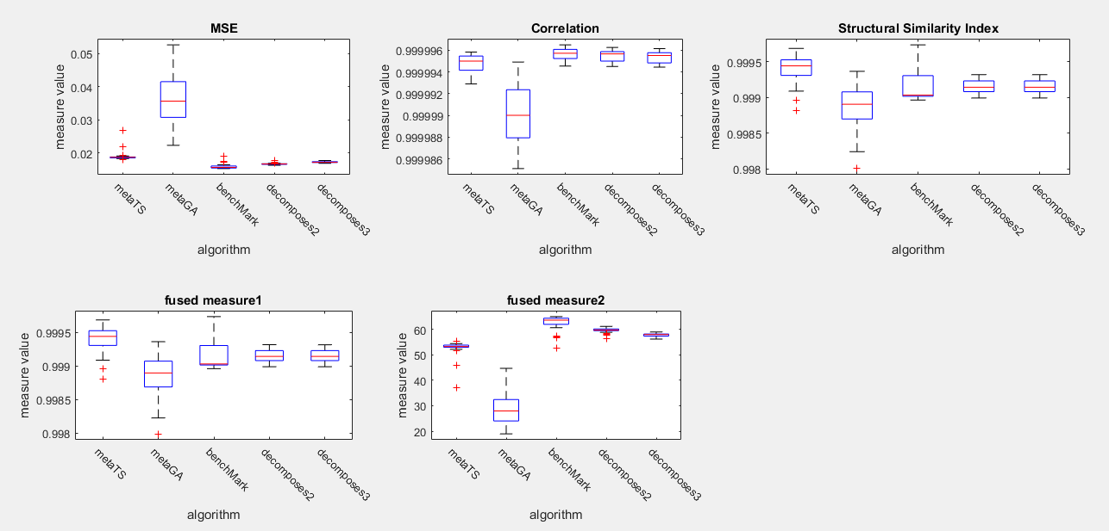Brain Dataset

We notice that the benchMark was the best in terms of MSE in this data, but Decomposed to 2 and 3 are superior in terms of structural similiarity. a possible factor that may affect the MSE of decomposed stegno that the benchMark embed the chromosom in the image, while we don’t embed the chromosome in our last developed metameric approach, and since we finally return to the benchMark and decompose the message to n sub message, there become n metameric, and those metamrics need to be embedded in the image as the benchMark algorithm does, this leads to increase the number of distored pixels, as well as the MSE, althouh we have used small values for n, but the difference between the decomposed approach and the benchMark is also small.

1. 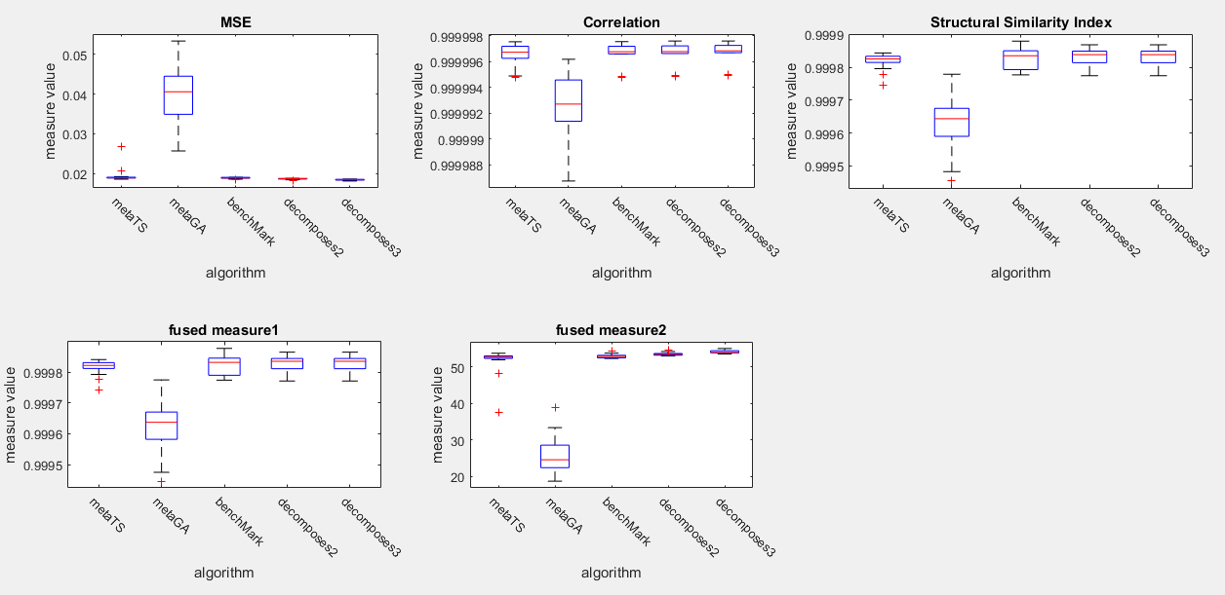Chest Dataset:

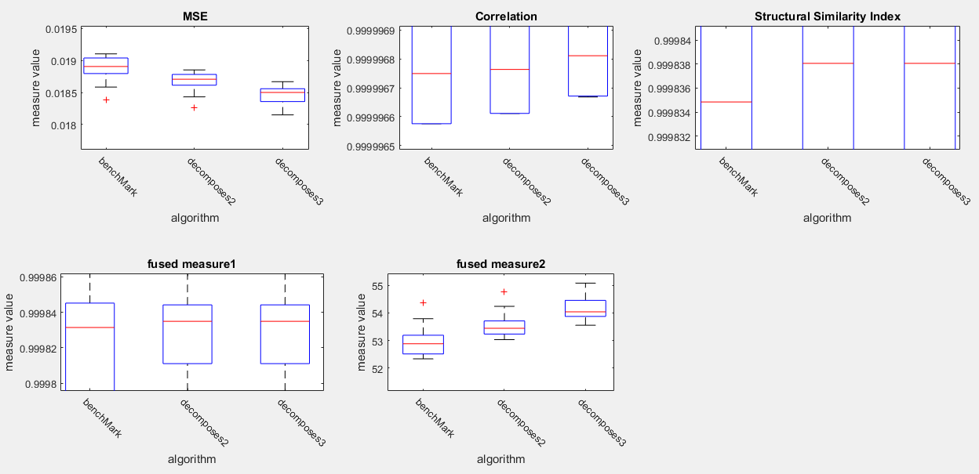By zooming in

We notice that the decomposed to 2 and 3 are superior in terms of all measures in the Chest data, I guess that decomposing of message is more effective in the more hetrogenious images like chest images.

- The results with metaGA_TS algorithm for chest data but only 2 images

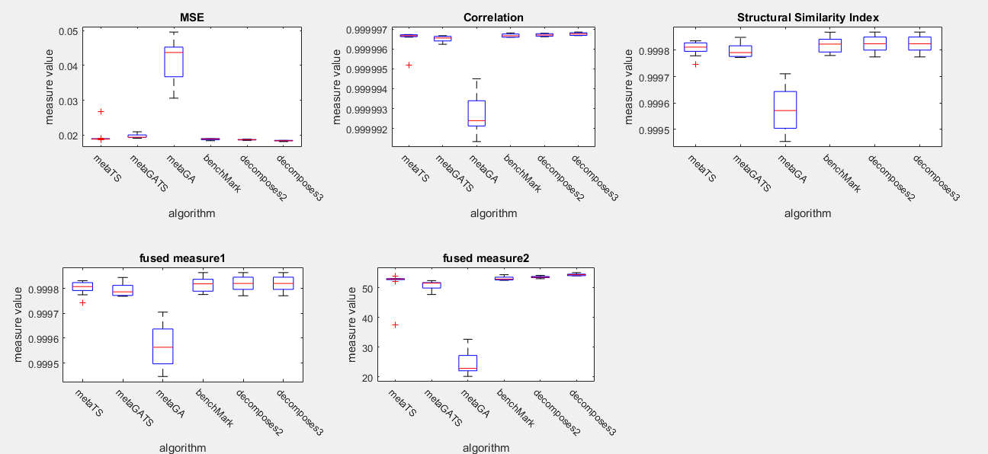

Security Measures Analysis:

1. 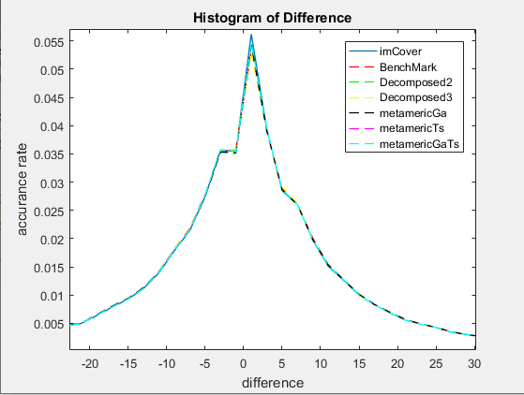Histogram of difference example:

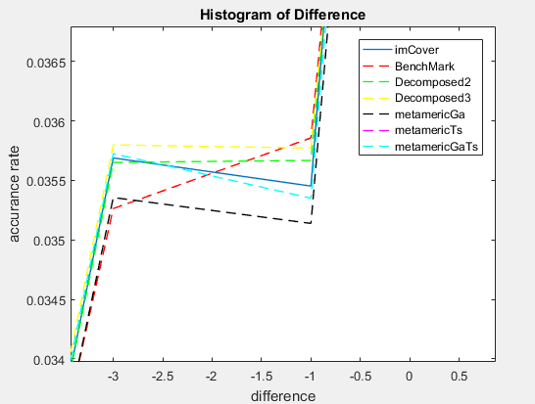Zooming in:

So, it is clear that there is no significant difference between the different approaches.

1. RS analysis example:

We took example of the best chromosom for random image and embidded the message gradually in the image cover with 100 steps. And used maske with size of 32 pixels

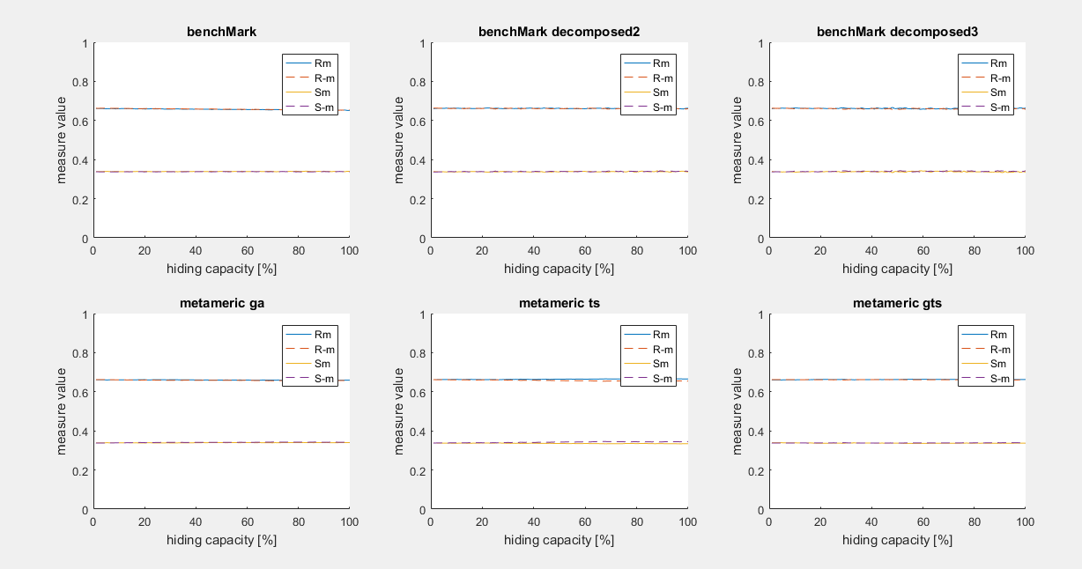

As we notice, there is also no significant difference between the different algorithms in terms of RS measure

1. Smoothness Measure:

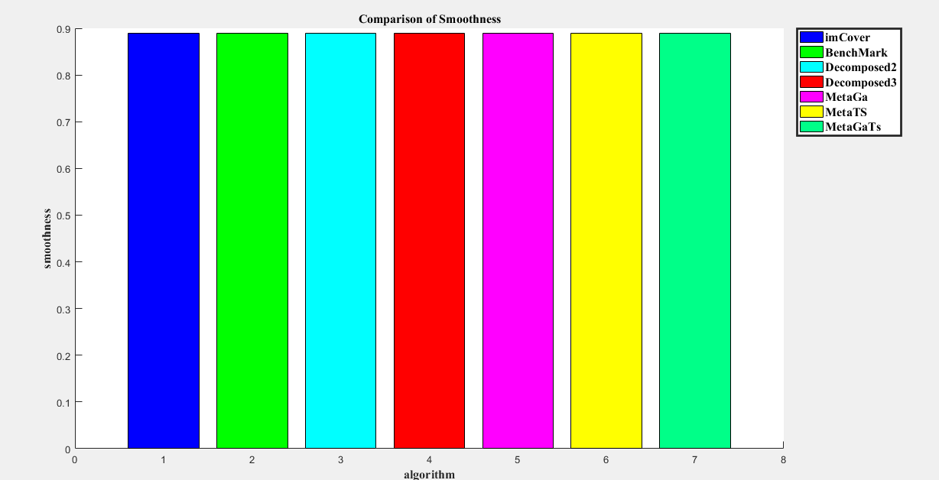

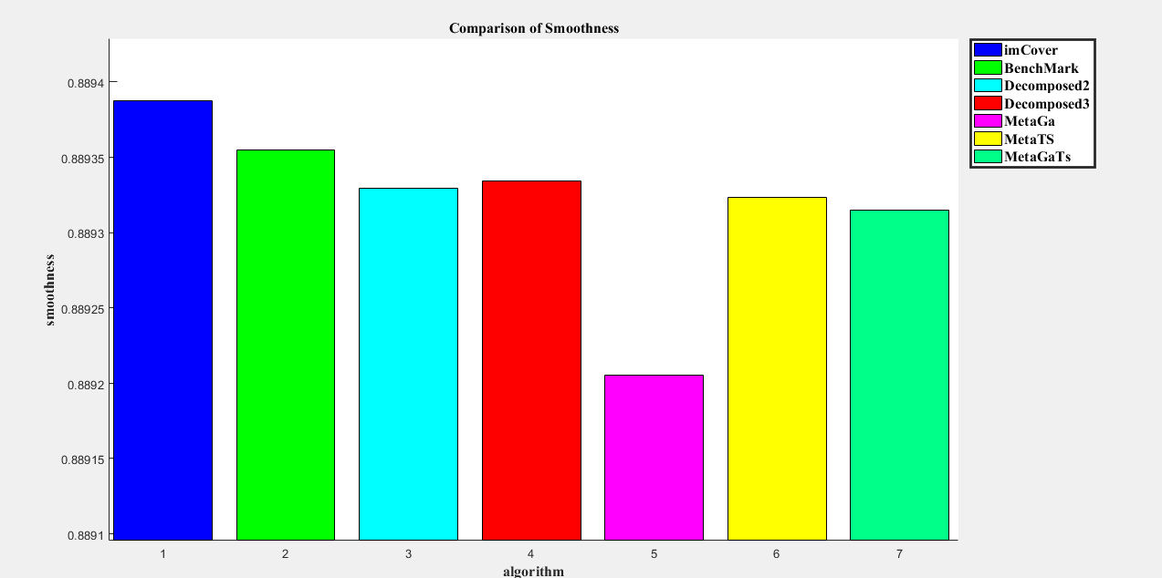Zooming in:

In this example, the benchMark approach is the best in terms of smoothness.